VD Design Link - https://xd.adobe.com/view/dbb0c028-0959-475f-6aea-a9c4d7c57cdf-ad81/

1. Home Screen

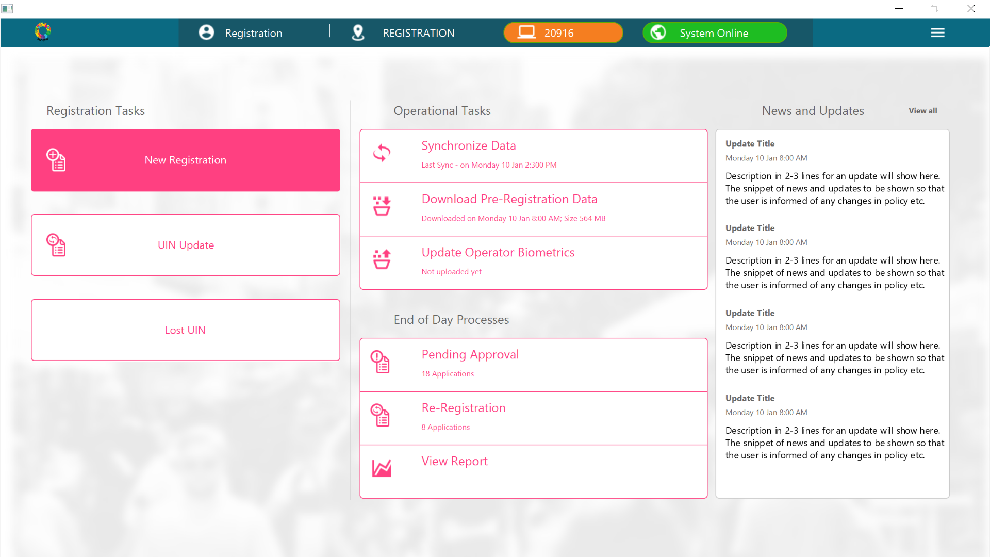

2.Biometric Exception

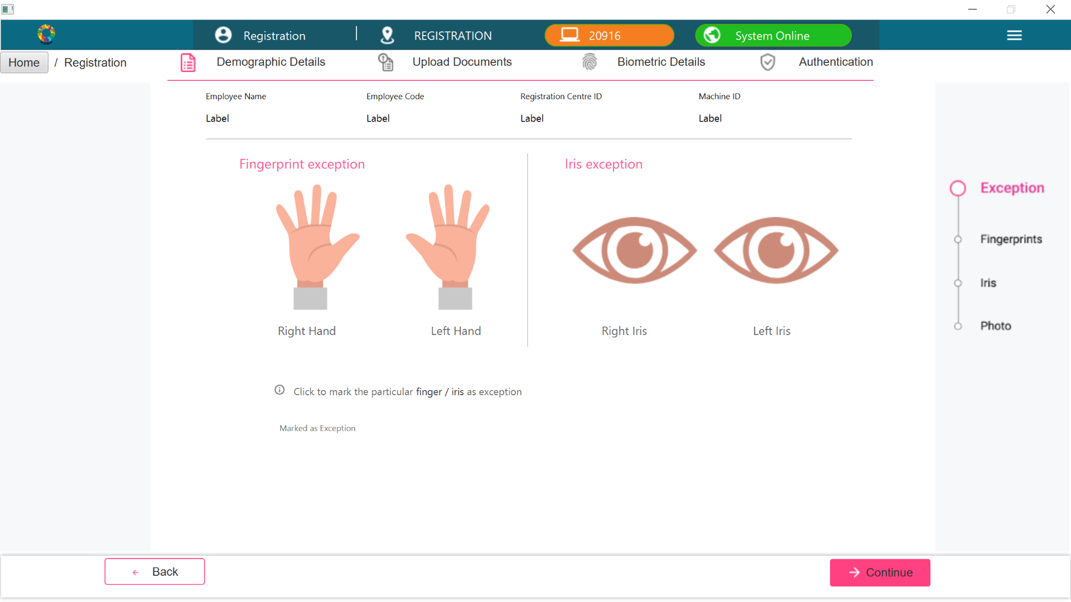

3.User Onboarding Operator Biometrics

